Assignment 1:

using System;

using System.Collections.Generic;

using System.Linq;

using System.Text;

using System.Threading.Tasks;

namespace day_14_assignment

{

class Program

{

static int display(int a1, int b1)

{

return a1 + b1;

}

static string display(string n, string s)

{

return n+" "+s;

}

static void display(int p)

{

Console.WriteLine("Percent : " + p);

if(p > 60)

{

Console.WriteLine("Grade A");

}

else if (p > 50 && p < 60)

{

Console.WriteLine("Grade B");

}

else if(p > 40 && p < 50)

{

Console.WriteLine("Grade C");

}

else

{

Console.WriteLine("Fail");

}

}

static void Main(string[] args)

{

Console.Write("Enter Name : ");

string name = Console.ReadLine();

Console.Write("Enter Surname : ");

string s_name = Console.ReadLine();

Console.Write("Enter A : ");

int a = int.Parse(Console.ReadLine());

Console.Write("Enter B : ");

int b = int.Parse(Console.ReadLine());

Console.Write("Enter Percent : ");

int per = int.Parse(Console.ReadLine());

string full_name = display(name, s_name);

Console.WriteLine("\n\nFull Name : " + full_name);

int sum = display(a, b);

Console.WriteLine("Sum : " + sum);

display(per);

Console.ReadKey();

}

}

}

Output:

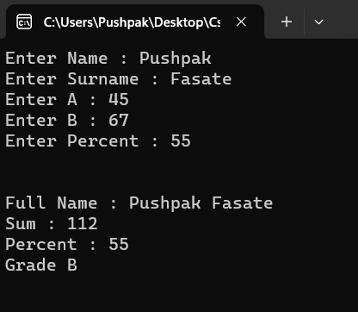

Assignment 2:

using System;

using System.Collections.Generic;

using System.Linq;

using System.Text;

using System.Threading.Tasks;

using System.Text;

namespace exception_try_catch_handling

{

class Program

{

public void display(int m1, int m2, int m3, int m4, int m5)

{

if(m1 == 0 && m2 == 0 && m3 == 0 && m4 == 0 && m5 == 0)

{

throw new Exception("Marks can not be 0");

}

//return m1 + m2 + m3 + m4 + m5;

}

static void Main(string[] args)

{

int num1, num2, num3, num4, num5;

Console.Write("Enter Mark 1 : ");

num1 = int.Parse(Console.ReadLine());

Console.Write("Enter Mark 2 : ");

num2 = int.Parse(Console.ReadLine());

Console.Write("Enter Mark 3 : ");

num3 = int.Parse(Console.ReadLine());

Console.Write("Enter Mark 4 : ");

num4 = int.Parse(Console.ReadLine());

Console.Write("Enter Mark 5 : ");

num5 = int.Parse(Console.ReadLine());

//comment exception handling

try

{

if (num1 == 0 || num2 == 0 || num3 == 0 || num4 == 0 || num5 == 0)

{

throw new Exception("Marks can not be 0");

}

int total = num1 + num2 + num3 + num4 + num5;

Console.WriteLine("Sum : " + total);

}

catch (Exception e)

{

Console.WriteLine(e);

}

Console.ReadKey();

}

}

}

Output:

